CAMPANY PROFILE

GEOMTEC GEOMATICS LIMITED

**PHYSICAL ADRESS**

P.O BOX: 100-38268 G.P.O

PHONE NO: +254701525253/

EMAIL:geomtecgeomatics@gmail.com

WEBSITE:WWW.GEOMTEGEOMATICS.ORG

**COMPANY DESCRIPTION**

The company engages both public and private sectors, in providing our services we endeavor to deliver beyond client expectations and satisfy our clients whilst rewarding all the stakeholders. The company is based in the services sector, including hiring surveying instruments, carrying out the calibration of the instruments, mutation, and reestablishment of lost beacons, land search, land registration process and acquisition of Title Deeds. The company also sell surveying instruments. The company ease and simplify the work for its customers by ensuring best services are offered.

The is registered under the 2015 Act as a Private Limited Company with one managing director.

The company goal is to make sure that the customers meet their demand and at the best quality. It is ensured that -the equipment hired and used to offer Land Surveying services to our customers are well maintained and gives the required accuracy per the manufacturer specifications and Survey Regulations Act.

**COMPANY REGISTRATION**

GEOMTEC GEOMATICS LIMITED was incorporated on June 2021 under the Company Registrations Act under the COMPANIES’ ACT OF 2015 in the republic of Kenya in the year 2021 under registration number PVT-27U5V2QE.

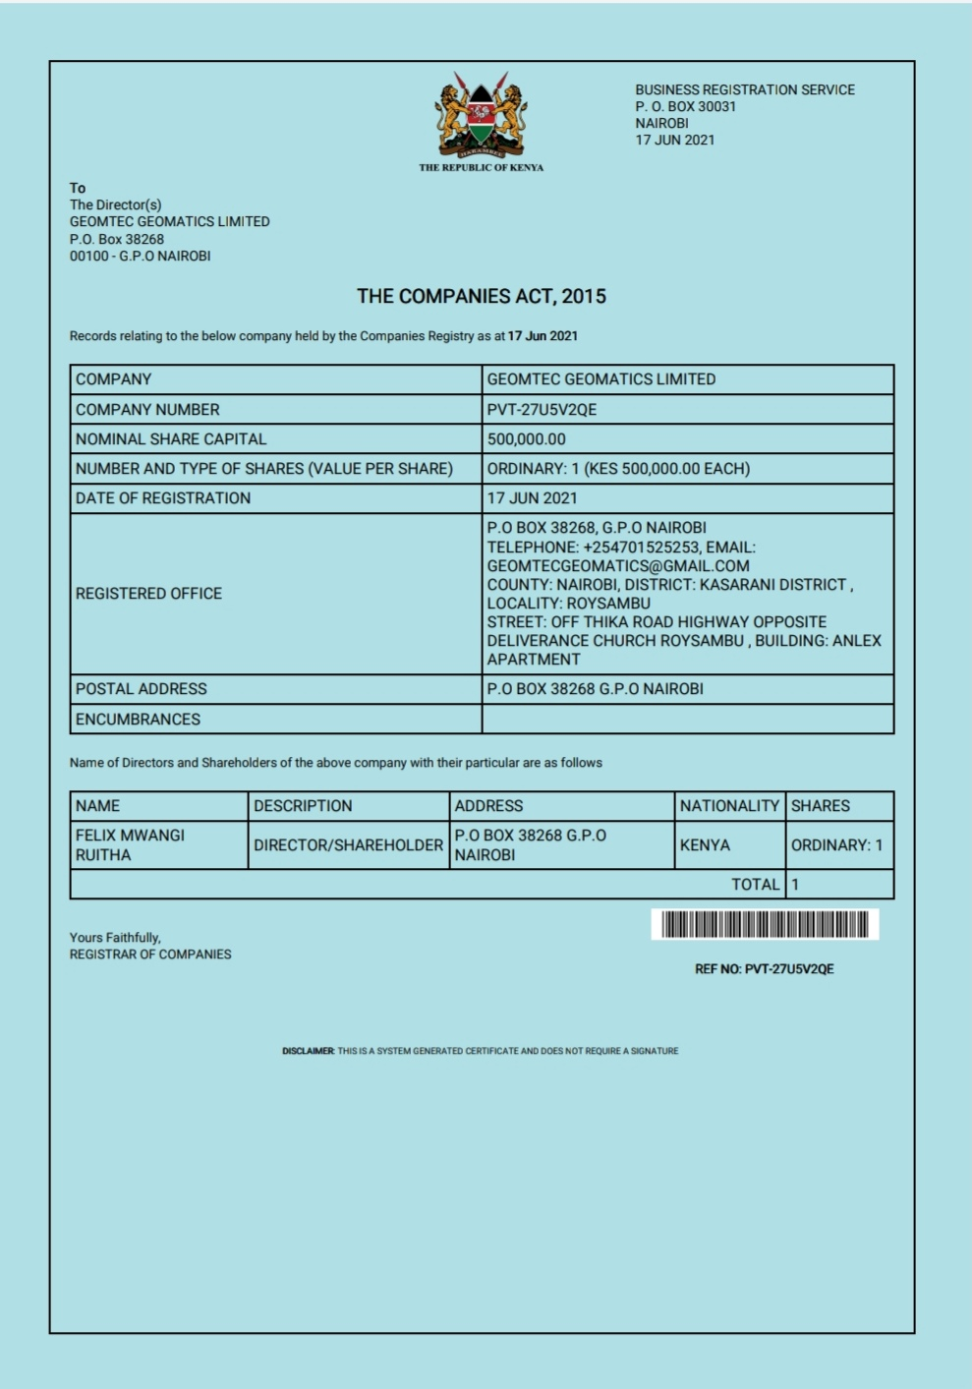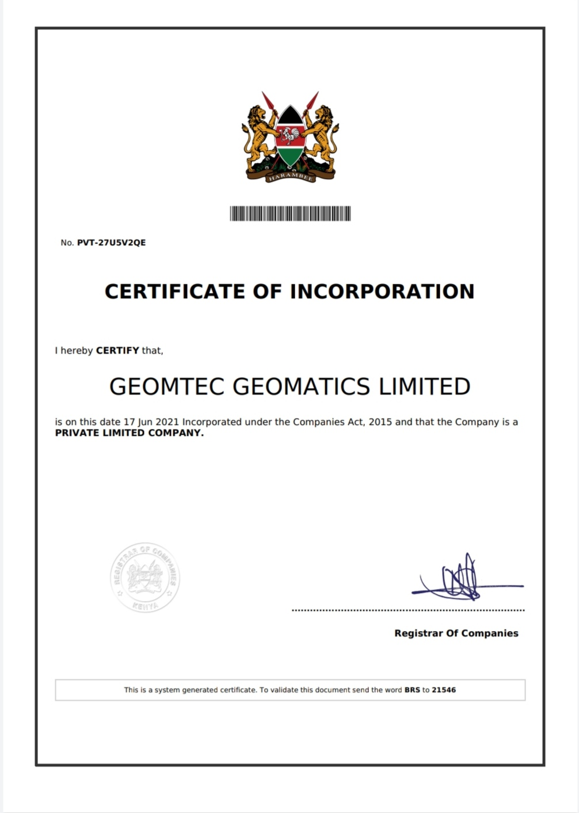

**COMPANY OBJECTSVES**

* To keep and retain customers in the business. This will be meet by ensuring that prices of services are subsidized so as to attract and maintain the customers.
* To offer and provide high quality services so as to attract, retain and serve more customers.
* To ensure and maintain wide region of market share.
* To provide the best quality services to our customers comparing to the other competitors in the market.
* To open other business branches to areas with more market to ensure that customer gets our services having no much struggle.

**MISSION**

To build a binding and continuous relationship with organizations seeking general supplies support solutions and provide them with continuous capabilities improvement through;

* Promoting and marketing quality goods,
* Maintaining reasonable and fixed prices.
* Implementing the “Added Value” policy by performing aftersales service to our customers.

**VISION**

Rise surveying standards using the advancing modern technologies …

**ORGANIZATON STRUCTURE PLAN**

Director

Accountant

Secretary

Assistant Manager

Guard

Cleaner

Supervisor